DAY8 SESSION ASSIGNMENTS (Theory)

1. When to use (Rapid Application Development) RAD model When not to use (Rapid Application Development) RAD model

Answers:

RAD is used when,

- we need to develop the product in fast in short time.
- If we do have a good experienced technology persons group and we can afford their cost.
- If we can afford the tools such as automatic code generator and all.
- When the requirement is changed and we need to give prototype in 2-3 months.

RAD is not used when,

- We don’t have expert team in our organisation.
- We don’t have budget to purchase the tool for automatic code generators.
- We need to deliver the product not the prototype.
- We have a large time to develop the protytype.

2. Define an ER diagram of a software Organization with all the relationship model that was discussed in the classroom
Emp_ID

Answers:
Bank
name
Salary
Amount
Loan
ID
Account
Number
Loan
Intrest
Salary
Account

n
1

has
takes
Dept. Name
Location
Name
No.of
employees
1
1
Employee
has
Emp_ID
1
n
Department
m
Department
ID
Address

Project
n
assigns

Project ID
Budget

Client
name

Annotations used here are:

Attributes - Entity - Relation -

n
m
Many to many relation - One to One relation -
1
1

n
One to many relation -
1

3. Describe the Entity Relationships for the following diagram
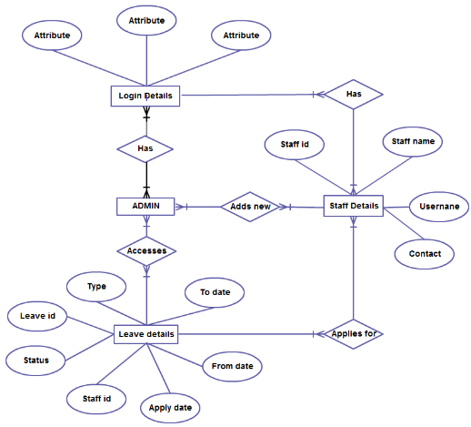

Answers:

- Login Details, Leave details, Admin , Staff details are the entities given in the diagram.

Staff details

- Many staff has differnt login that is many to many relation.
- Many staff applies for many leaves that is many to many relation.
- Staff details has staff name,user name,contacts,staff id.Here staff id is the primary key which is unique.

Admin

- Admins add new staffs that is many to many relation.
- Leave deatils can be accessed by Admin this is many to many relation.
- Admin has relationship with Login deatils. He can login into his account.

Leave details

- Leave deatils has the following attributes type,leave id,status,staff id,apply date,from date,to date. Here leave id is unique.
- The foreign key staff id used in this entity.
- Leave is accesed by admin.

Login Details is in contact with Admin and staff.

The main flow here is both admin and staff has login details. Staff can apply for leaves. Admin can add new staffs.

